Column: BPG News
Author: Jin-Lei Wang
Proof: Lian-Sheng Ma
Title: 百世登旗下的6种ESCI期刊明年6月将获得首个影响因子
Date: August 30, 2022

百世登旗下的6种ESCI期刊明年6月将获得首个影响因子

Abstract
根据科睿唯安2022年7月26日正式公告，2023年度《期刊引证报告》（Journal Citation Reports，简称JCR）将对Web of Science核心合集收录的所有期刊赋予期刊影响因子。这意味着Emerging Sources Citation Index（ESCI）收录的期刊将在2023年获得期刊影响因子。在此，我们很高兴地宣布ESCI从2017-07-19收录了百世登旗下6种期刊，包括World Journal of Orthopedics (WJO), World Journal of Clinical Oncology (WJCO), World Journal of Hepatology (WJH), World Journal of Cardiology (WJC), World Journal of Gastrointestinal Endoscopy (WJGE) and World Journal of Radiology (WJR)。这6种期刊将会在明年6月得首个影响因子。过去3年里，这6本期刊在作者，读者，编委，同行评议人，离职编辑和在职员编辑的支持下取得了很大的进步，包括(1) The number of articles received, articles published of the six journals have significantly increased in 2021. Such as, the number of articles received in WJH in 2021 was 93.2% higher than that in the years of 2019-2020, and the number of articles published in WJH in 2021 was 73.1% higher than that in the years of 2019-2020; (2) The average times cited per item of the six journals are all > 5. Such as, 672 articles published in WJH have been cited 5496 times, the average per item is 8.18; (3) Some of the articles published in the six journals in 2019-2021 have been cited by articles published in internationally renowned academic journals, such as JAMA, Nature Reviews Gastroenterology Hepatology, and Nature Reviews Clinical Oncology, etc.; (4) The 2022 Journal Article Influence Index (2022 JAII) of the six journals are all > 10. Such as, WJO has a 2022 JAII of 15.410, ranking 31st out of 104 journals in the field of orthopedics in the Reference Citation Analysis; (5) Most of the authors of the articles published in the six journals in 2019-2021 are came from developed countries, such as United States (33.9%, 397/1171), and United Kingdom (7.8%, 91/1171), etc.; and (6) The number of webpage visits and downloads received of the six journals have significantly increased in year by year. Such as, WJCO received visits from more than 180 countries and regions worldwide, and the number of visits in 2020 increased by 46.6% compared with that in 2019, the number of visits in 2021 increased by 29.1% compared with that in 2020. The downloads of WJO came from more than 160 countries and regions worldwide, and the number of downloads in 2020 increased by 91.8% compared with that in 2019, the number of downloads in 2021 increased by 41.7% compared with that in 2020. In this study, we introduced the number of received and published articles, ESCI citations data, 2022 JAII, and number of webpage visits and downloads for the six journals in 2019-2021.

INTRODUCTION
根据科睿唯安2022年7月26日正式公告，2023年度《期刊引证报告》（Journal Citation Reports，简称JCR）将对Web of Science核心合集收录的所有期刊赋予期刊影响因子。这意味着期刊影响因子的覆盖范围将从科学引文索引扩展版（SCIE）和社会科学引文索引（SSCI）期刊扩大到艺术与人文引文索引（AHCI）和多学科的Emerging Sources Citation Index（ESCI）期刊^{[1]}。在此，我们很高兴地宣布ESCI从2017-07-19收录了百世登旗下6种期刊，包括World Journal of Orthopedics (WJO), World Journal of Clinical Oncology (WJCO), World Journal of Hepatology (WJH), World Journal of Cardiology (WJC), World Journal of Gastrointestinal Endoscopy (WJGE) and World Journal of Radiology (WJR)。同时，这些期刊也已经被PubMed收录。这6种期刊将会在明年6月得首个影响因子。当前影响因子是评价学术期刊影响力的一个重要指标。我们要在这里特别感谢作者，读者，编委，同行评议人，离职编辑和在职员编辑的十几年的持续热情支持和学术贡献！
Now, in order to enable the authors, peer reviewers, editorial members and readers to better understand the publishing status of these six journals, we introduce the number of received and published articles, ESCI citations data, 2022 Journal Article Influence Index (2022 JAII, calculated as Total Citations/Total Articles), and number of webpage visits and downloads for the six journals in 2019-2021 as follows.

1 Number of received and published articles, ESCI citations data, 2022 JAII, author sources, and number of webpage visits and downloads for WJO in 2019-2021
1.1 Number of received and published articles of WJO in 2019-2021
From 2019 to 2021, WJO received a total of 668 articles, among which 260 (38.9%) were invited and 408 (61.1%) were freely submitted; the acceptance rate was 31.4%. During that same period, WJO published 210 articles, among which 87 (41.4%) were invited and 123 (58.6%) were freely submitted. The number of articles received in WJO in 2021 was 44.8% higher than that in the years of 2019-2020 (2019-2020 average: 194/year vs 2021: 281/year), and the number of articles published in WJO in 2021 was 75.0% higher than that in the years of 2019-2020 (2019-2020 average: 56/year vs 2021: 98/year).

1.2 ESCI citations for WJO published articles in 2019-2021
According to the Web of Science, Web of Science included a total of 418 articles published in WJO from 2017 to August 24, 2022. These articles have been cited 2259 times (Without self-citations: 2227) by 2213 articles (Without self-citations: 2188), average per item is 5.4.
As of August 24, 2022, the 210 articles published in WJO in 2019-2021 received a total of 632 citations (without self-citations: 622) by 624 articles (without self-citations: 615), yielding a self-citation rate of 1.58%; there were a total of 242 citations in 2021 and 252 citations in 2022 (data from Web of Science). After excluding self-citations, the 615 articles that cited the WJO-published articles were from 459 journals (data from Web of Science, Table 1); among these journals, 11 (2.4%) had a JIF of > 10 (data from Web of Science, Table 2), accounting for 1.7% of the 660 total journals that had received a JIF of > 10 in the JCR 2022. Moreover, the journals citing the WJO-published articles include two journals with JIF > 15, Advanced Science (2021 JIF 17.521, record count: 1) and Bioactive Materials (2021 JIF 16.874, record count: 1).

Table 1 Rank and record count of journals that published articles that cited the 210 articles published in World Journal of Orthopedics in 2019-2021
Rank | Publication/source titles | Record count | % of 615
1 | Injury | 28 | 4.553
2 | Journal of Arthroplasty | 28 | 4.553
3 | European Journal of Orthopaedic Surgery and Traumatology | 16 | 2.602
4 | Diagnostics | 14 | 2.276
5 | BMC Musculoskeletal Disorders | 12 | 1.951
6 | Journal of Clinical Medicine | 12 | 1.951
7 | Cureus | 11 | 1.789
8 | Journal of Orthopaedic Surgery and Research | 10 | 1.626
9 | Bone Joint Journal | 10 | 1.626
10 | Archives of Osteoporosis | 9 | 1.463
11 | Cureus Journal of Medical Science | 8 | 1.301
12 | Nutrients | 8 | 1.301
13 | Osteoporosis International | 8 | 1.301
14 | Archives of Orthopaedic and Trauma Surgery | 7 | 1.138
15 | Osteoporosis International | 7 | 1.138
16 | Clinical Orthopaedics and Related Research | 6 | 0.976
17 | International Journal of Molecular Sciences | 6 | 0.976
18 | International Orthopaedics | 6 | 0.976
19 | JBJS Reviews | 5 | 0.813
20 | Other journals | 404 | 65.691

Table 2 Rank and record count of the 11 journals with a 2021 Journal Impact Factor of > 10 that cited the articles published in World Journal of Orthopedics in 2019-2021
Rank | Publication/source titles | 2021 JIF | Record count
1 | Advanced Science | 17.521 | 1
2 | Bioactive Materials | 16.874 | 1
3 | Anaesthesia | 12.893 | 1
4 | Age and Ageing | 12.782 | 2
5 | Medical Journal of Australia | 12.776 | 1
6 | PLOS Medicine | 11.613 | 1
7 | Advances in Nutrition | 11.567 | 1
8 | Drugs | 11.431 | 1
9 | Redox Biology | 10.787 | 1
10 | Carbohydrate Polymers | 10.723 | 1
11 | Acta Biomaterialia | 10.633 | 1

Of note, the article entitled ”Optimization of transdisciplinary management of elderly with femur proximal extremity fracture: A patient-tailored plan from orthopaedics to rehabilitation”, which was contributed by Dr. Alessandro de Sire et al^{[2]} from University of Catanzaro “Magna Graecia” in the Italy, is the article with the highest number of citations among the articles published in WJO in 2021. This article summarizes current evidence supporting transdisciplinary management of patients with fractures of femur proximal extremity, highlighting the benefits, feasibility, and limitations of this approach. As of August 24, 2022, this article has been cited 16 times.

1.3 2022 JAII of WJO
According to Reference Citation Analysis (RCA) database, independently developed by Baishideng, WJO has a 2022 JAII of 15.410, ranking 31st out of 104 journals in the field of orthopedics in the RCA, with 13592 total citations (52/104) and 882 total articles (78/104) (Figure 1).
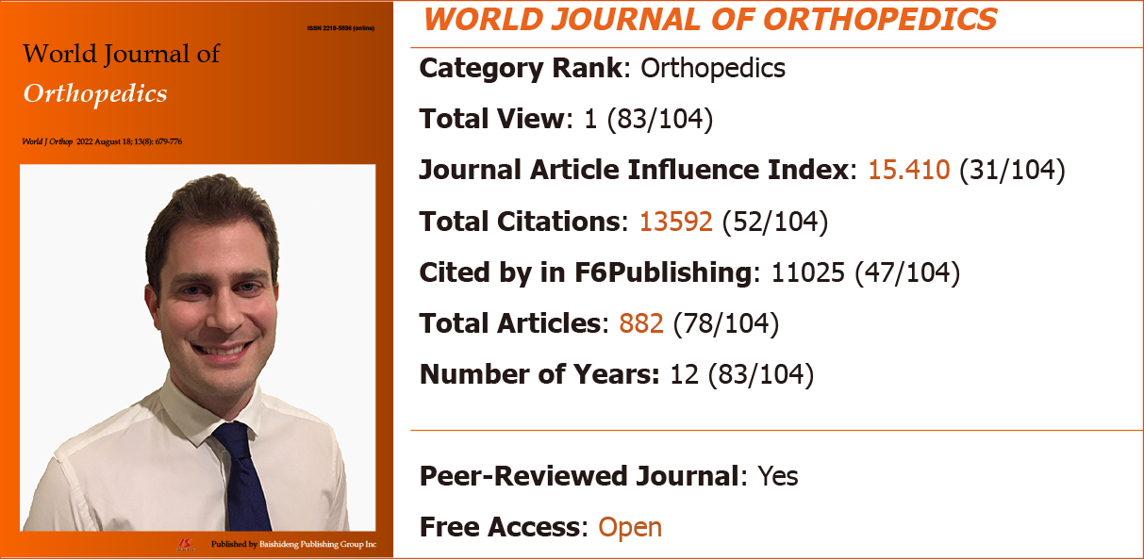
Figure 1 The 2022 Journal Article Influence Index and category rank of World Journal of Orthopedics.

1.4 Author sources for WJO published articles in 2019-2021
From 2019 to 2021, the authors of the 210 articles published in WJO came from 44 countries/regions, represented by 61 articles (29.0%) from United States, 28 (13.3%) from Italy, 25 (11.9%) from the United Kingdom, 13 (6.2%) from Greece, 8 (3.8%) from France, 8 (3.8%) from India, 8 (3.8%) from Iran, 8 (3.8%) from Netherlands, and 51 (24.3%) from other countries/regions (data from Web of Science, Figure 2).

Figure 2 Country sources and number of articles published in World Journal of Orthopedics in 2019-2021. WJO: World Journal of Orthopedics.

1.5 Number of webpage visits and downloads received by WJO in 2019-2021
From 2019 to 2021, the WJO webpage received a total number of visits of 187531 in 2019, 254463 in 2020 (increased by 35.7% compared with that in 2019), and 261540 in 2021 (increased by 2.8% compared with that in 2020), with the visits coming from more than 200 countries and regions worldwide (Table 3). The number of downloads was 91925 in 2019, 176327 in 2020 (increased by 91.8% compared with that in 2019), and 249778 in 2021 (increased by 41.7% compared with that in 2020), with the downloads coming from more than 160 countries and regions worldwide.

Table 3 Rank of number of visits for World Journal of Orthopedics webpage from main countries/regions in 2019-2021
Rank | 2019 |  | 2020 |  | 2021
 | Country/region | Visits, n (%) | Country/region | Visits, n (%) | Country/region | Visits, n (%)
1 | United States | 64229 (34.2) | United States | 66681 (26.2) | United States | 79302 (30.3)
2 | United Kingdom | 24838 (13.2) | United Kingdom | 27482 (10.8) | China | 26618 (10.2)
3 | China | 16722 (8.9) | China | 23651 (9.3) | United Kingdom | 14405 (5.5)
4 | Russia | 8934 (4.7) | Russia | 12161 (4.8) | India | 14262 (5.5)
5 | India | 8140 (4.3) | India | 9436 (3.7) | South Korea | 9905 (3.8)
6 | Australia | 5679 (3.0) | Germany | 6543 (2.6) | Australia | 7823 (3.0)
7 | Ukraine | 4083 (2.2) | Australia | 6384 (2.5) | Germany | 7431 (2.8)
8 | Canada | 3781 (2.0) | Canada | 4868 (1.9) | Russia | 6752 (2.6)
9 | Germany | 3759 (2.0) | Hong Kong | 4791 (1.9) | Canada | 6241 (2.4)
10 | Russian Federation | 3734 (2.0) | Netherlands | 4020 (1.6) | Netherlands | 5311 (2.0)

2 Number of received and published articles, ESCI citations data, 2022 JAII, author sources, and number of webpage visits and downloads for WJCO in 2019-2021
2.1 Number of received and published articles of WJCO in 2019-2021
From 2019 to 2021, WJCO received a total of 469 articles, among which 274 (58.4%) were invited and 195 (41.6%) were freely submitted; the acceptance rate was 45.6%. During that same period, WJCO published 214 articles, among which 148 (69.2%) were invited and 66 (30.8%) were freely submitted. The number of articles received in WJCO in 2021 was 13.3% higher than that in the years of 2019-2020 (2019-2020 average: 150/year vs 2021: 170/year), and the number of articles published in WJCO in 2021 was 46.8% higher than that in the years of 2019-2020 (2019-2020 average: 62/year vs 2021: 91/year).

2.2 ESCI citations for WJCO published articles in 2019-2021
According to the Web of Science, Web of Science included a total of 322 articles published in WJCO from 2017 to August 24, 2022. These articles have been cited 2055 times (Without self-citations: 2037) by 2035 articles (Without self-citations: 2018), average per item is 6.38.
As of August 24, 2022, the 214 articles published in WJCO in 2019-2021 received a total of 839 citations (without self-citations: 836) by 825 articles (without self-citations: 822), yielding a self-citation rate of 0.36%; there were a total of 346 citations in 2021 and 331 citations in 2022 (data from Web of Science). After excluding self-citations, the 822 articles that cited the WJCO-published articles were from 606 journals (data from Web of Science, Table 4); among these journals, 32 (5.3%) had a JIF of > 10 (data from Web of Science, Table 5), accounting for 4.8% of the 660 total journals that had received a JIF of > 10 in the JCR 2022. Moreover, the journals citing the WJCO-published articles include internationally renowned academic journals such as Nature Reviews Clinical Oncology (2021 JIF 65.011, record count: 1), Lancet Oncology (2021 JIF 54.433, record count: 4), Nature Reviews Endocrinology (2021 JIF 47.564, record count: 1), and Molecular Cancer (2021 JIF 41.444, record count: 1).

Table 4 Rank and record count of journals that published articles that cited the 214 articles published in World Journal of Clinical Oncology in 2019-2021
Rank | Publication/source titles | Record count | % of 822
1 | Cancers | 68 | 8.273
2 | Frontiers in Oncology | 36 | 4.380
3 | International Journal of Molecular Sciences | 26 | 3.163
4 | In Vivo | 15 | 1.825
5 | Radiotherapy and Oncology | 12 | 1.460
6 | Medicine | 10 | 1.217
7 | Revista Brasileira de Ginecologia e Obstetricia | 10 | 1.217
8 | Biomedicines | 8 | 0.973
9 | Current Oncology | 8 | 0.973
10 | Scientific Reports | 7 | 0.852
11 | Cureus | 6 | 0.730
12 | Frontiers in Immunology | 6 | 0.730
13 | BMJ Case Reports | 5 | 0.608
14 | Cancer Management and Research | 5 | 0.608
15 | Cells | 5 | 0.608
16 | Radiotherapy Oncology | 5 | 0.608
17 | Translational Lung Cancer Research | 5 | 0.608
18 | American Journal of Cancer Research | 4 | 0.487
19 | BMC Cancer | 4 | 0.487
20 | Clinical Case Reports | 4 | 0.487
21 | Clinical Nuclear Medicine | 4 | 0.487
22 | Critical Reviews in Oncology Hematology | 4 | 0.487
23 | Cureus Journal of Medical Science | 4 | 0.487
24 | Frontiers in Cell and Developmental Biology | 4 | 0.487
25 | Frontiers in Genetics | 4 | 0.487
26 | Other journals | 553 | 67.275

Table 5 Rank and record count of the 32 journals with a 2021 Journal Impact Factor of > 10 that cited the articles published in World Journal of Clinical Oncology in 2019-2021
Rank | Publication/source titles | 2021 JIF | Record count
1 | Nature Reviews Clinical Oncology | 65.011 | 1
2 | Lancet Oncology | 54.433 | 4
3 | Nature Reviews Endocrinology | 47.564 | 1
4 | Molecular Cancer | 41.444 | 1
5 | Cancer Cell | 38.585 | 1
6 | Signal Transduction and Targeted Therapy | 38.104 | 2
7 | Gastroenterology | 33.883 | 4
8 | American Journal of Respiratory and Critical Care Medicine | 30.528 | 1
9 | International Journal of Oral Science | 24.897 | 1
10 | European Urology | 24.267 | 1
11 | Journal of Thoracic Oncology | 20.121 | 2
12 | Journal of Clinical Investigation | 19.456 | 1
13 | Advanced Science | 17.521 | 1
14 | Journal of Extracellular Vesicles | 17.337 | 1
15 | Hepatology | 17.298 | 1
16 | Seminars in Cancer Biology | 17.012 | 4
17 | Nature Reviews Urology | 16.430 | 1
18 | Molecular Aspects of Medicine | 16.337 | 1
19 | Trends in Biochemical Sciences | 14.264 | 1
20 | EMBO Molecular Medicine | 14.260 | 1
21 | Annals of Surgery | 13.787 | 1
22 | Cancer Treatment Reviews | 13.608 | 2
23 | JAMA Network Open | 13.353 | 3
24 | Leukemia | 12.883 | 1
25 | Proceedings of the National Academy of Sciences of the United States of America | 12.779 | 2
26 | Journal for Immunotherapy of Cancer | 12.469 | 3
27 | Biochimica et Biophysica Acta Reviews on Cancer | 11.414 | 2
28 | Journal of Nuclear Medicine | 11.082 | 1
29 | Clinical Nuclear Medicine | 10.782 | 4
30 | Matrix Biology | 10.447 | 1
31 | Chest | 10.262 | 1
32 | European Journal of Nuclear Medicine and Molecular Imaging | 10.057 | 1

Of note, the article entitled ”Oncogenic driver mutations in non-small cell lung cancer: Past, present and future”, which was contributed by Dr. Mathieu Chevallier et al^{[3]} from University Hospital Geneva in the Switzerland, is the article with the highest number of citations among the articles published in WJCO in 2021. This article provides an update about the current landscape of driver mutation in non-small-cell lung cancer. As of August 24, 2022, this article has been cited 12 times.

2.3 2022 JAII of WJCO
According to the RCA database, WJCO has a 2022 JAII of 14.620 ranking 111th out of 291 journals in the field of oncology in the RCA, with 9357 total citations (198/291) and 640 total articles (223/291) (Figure 3).
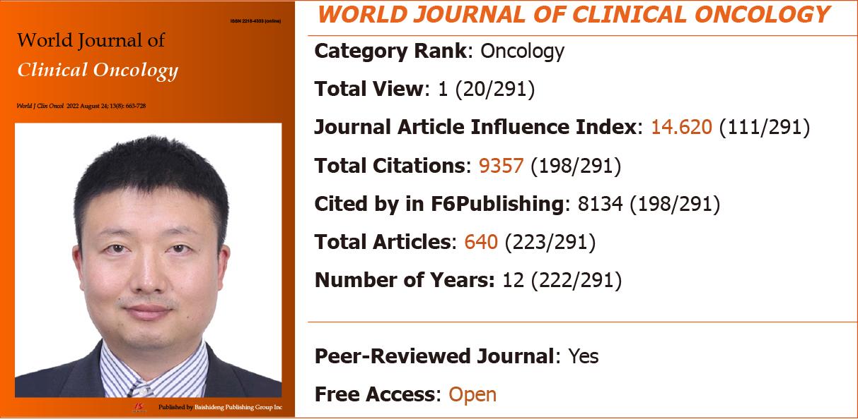
Figure 3 The 2022 Journal Article Influence Index and category rank of World Journal of Clinical Oncology.

2.4 Author sources for WJCO published articles in 2019-2021
From 2019 to 2021, the authors of the 214 articles published in WJCO came from 47 countries/regions, represented by 59 articles (27.6%) from United States, 27 (12.6%) from the Spain, 17 (7.9%) from Italy, 12 (5.6%) from United Kingdom, 11 (5.1%) from India, 10 (4.7%) from Brazil, 9 (4.2%) from Japan, 8 (3.7%) from China, and 61 (28.5%) from other countries/regions (data from Web of Science, Figure 4).

Figure 4 Country sources and number of articles published in World Journal of Clinical Oncology in 2019-2021. WJCO: World Journal of Clinical Oncology.

2.5 Number of webpage visits and downloads received by WJCO in 2019-2021
From 2019 to 2021, the WJCO webpage received a total number of visits of 82452 in 2019, 120905 in 2020 (increased by 46.6% compared with that in 2019), and 156078 in 2021 (increased by 29.1% compared with that in 2020), with the visits coming from more than 180 countries and regions worldwide (Table 6). The number of downloads was 49107 in 2019, 101240 in 2020 (increased by 106.2% compared with that in 2019), and 157857 in 2021 (increased by 55.9% compared with that in 2020), with the downloads coming from more than 140 countries and regions worldwide.

Table 6 Rank of number of visits for World Journal of Clinical Oncology webpage from main countries/regions in 2019-2021
Rank | 2019 |  | 2020 |  | 2021
 | Country/region | Visits, n (%) | Country/region | Visits, n (%) | Country/region | Visits, n (%)
1 | United States | 18855 (22.9) | United States | 21823 (18.0) | United States | 43180 (27.7)
2 | China | 14788 (17.9) | United Kingdom | 14701 (12.2) | China | 20666 (13.2)
3 | United Kingdom | 9555 (11.6) | China | 14434 (11.9) | India | 7267 (4.7)
4 | Russia | 6173 (7.5) | Russia | 7624 (6.3) | United Kingdom | 7141 (4.6)
5 | India | 3455 (4.2) | India | 4057 (3.4) | South Korea | 5861 (3.8)
6 | Ukraine | 2815 (3.4) | Germany | 3573 (3.0) | Spain | 4743 (3.0)
7 | South Korea | 2200 (2.7) | Hong Kong | 2664 (2.2) | Germany | 4736 (3.0)
8 | Germany | 1996 (2.4) | France | 1878 (1.6) | Russia | 4562 (2.9)
9 | France | 1649 (2.0) | Spain | 1791 (1.5) | Japan | 3629 (2.3)
10 | Japan | 1271 (1.5) | Italy | 1738 (1.4) | Italy | 3075 (2.0)

3 Number of received and published articles, ESCI citations data, 2022 JAII, author sources, and number of webpage visits and downloads for WJH in 2019-2021
3.1 Number of received and published articles of WJH in 2019-2021
From 2019 to 2021, WJH received a total of 751 articles, among which 380 (50.6%) were invited and 371 (49.4%) were freely submitted; the acceptance rate was 46.1%. During that same period, WJH published 346 articles, among which 204 (59.0%) were invited and 142 (41.0%) were freely submitted. The number of articles received in WJH in 2021 was 93.2% higher than that in the years of 2019-2020 (2019-2020 average: 191/year vs 2021: 369/year), and the number of articles published in WJH in 2021 was 73.1% higher than that in the years of 2019-2020 (2019-2020 average: 93/year vs 2021: 161/year).

3.2 ESCI citations for WJH published articles in 2019-2021
According to the Web of Science, Web of Science included a total of 672 articles published in WJH from 2017 to August 24, 2022. These articles have been cited 5496 times (Without self-citations: 5401) by 5227 articles (Without self-citations: 5145), average per item is 8.18.
As of August 24, 2022, the 346 articles published in WJH in 2019-2021 received a total of 1462 citations (without self-citations: 1438) by 1390 articles (without self-citations: 1373), yielding a self-citation rate of 1.6%; there were a total of 639 citations in 2021 and 477 citations in 2021 (data from Web of Science). After excluding self-citations, the 1373 articles that cited the WJH-published articles were from 874 journals (data from Web of Science, Table 7); among these journals, 47 (5.4%) had a JIF of > 10 (data from Web of Science, Table 8), accounting for 7.1% of the 660 total journals that had received a JIF of > 10 in the JCR 2022. Moreover, the journals citing the WJH-published articles include internationally renowned academic journals such as JAMA (2021 JIF 157.335, record count: 1), Nature Reviews Gastroenterology Hepatology (2021 JIF 73.082, record count: 4), Annals of Internal Medicine (2021 JIF 51.598, record count: 1), Nature Reviews Cardiology (2021 JIF 49.421, record count: 1), Nature Reviews Endocrinology (2021 JIF 47.564, record count: 1), and Lancet Gastroenterology Hepatology (2021 JIF 45.042, record count: 1).

Table 7 Rank and record count of journals that published articles that cited the 346 articles published in World Journal of Hepatology in 2019-2021
Rank | Publication/source titles | Record count | % of 1373
1 | International Journal of Molecular Sciences | 47 | 3.423
2 | Liver international | 32 | 2.331
3 | World Journal of Gastroenterology | 29 | 2.112
4 | Journal of Clinical Medicine | 28 | 2.039
5 | Cancers | 27 | 1.966
6 | Nutrients | 26 | 1.894
7 | Biomedicines | 24 | 1.748
8 | Diagnostics | 22 | 1602
9 | Abdominal radiology | 18 | 1.311
10 | Cureus | 16 | 1.165
11 | Frontiers in Pharmacology | 14 | 1.02
12 | Frontiers in Oncology | 13 | 0.947
13 | Scientific reports | 11 | 0.801
14 | Digestive Diseases and Sciences | 9 | 0.655
15 | Journal of Gastrointestinal Cancer | 9 | 0.655
16 | Cureus Journal of Medical Science | 8 | 0.583
17 | Frontiers in Medicine | 8 | 0.583
18 | World Journal of Clinical Cases | 8 | 0.583
19 | Annals of Translational Medicine | 7 | 0.510
20 | Cells | 7 | 0.510
21 | Frontiers in Endocrinology | 7 | 0.510
22 | Frontiers in Immunology | 7 | 0.510
23 | Organ transplantation | 7 | 0.510
24 | Other journals | 989 | 72.032

Table 8 Rank and record count of the 47 journals with a 2021 Journal Impact Factor of > 10 that cited the articles published in World Journal of Hepatology in 2019-2021
Rank | Publication/source titles | 2021 JIF | Record count
1 | JAMA | 157.335 | 1
2 | Nature Reviews Gastroenterology Hepatology | 73.082 | 4
3 | Annals of Internal Medicine | 51.598 | 1
4 | Nature Reviews Cardiology | 49.421 | 1
5 | Nature Reviews Endocrinology | 47.564 | 1
6 | Lancet Gastroenterology Hepatology | 45.042 | 1
7 | Molecular Cancer | 41.444 | 1
8 | Circulation | 39.918 | 1
9 | Signal Transduction and Targeted Therapy | 38.104 | 2
10 | Gastroenterology | 33.883 | 1
11 | Gut | 31.793 | 1
12 | Journal of Hepatology | 30.083 | 6
13 | Endocrine Reviews | 25.261 | 1
14 | Annual Review of Physiology | 22.163 | 1
15 | Journal of Medical Virology | 20.693 | 1
16 | Critical Care | 19.334 | 1
17 | Molecular Neurodegeneration | 18.879 | 1
18 | Advanced Drug Delivery Reviews | 17.873 | 1
19 | Hepatology | 17.298 | 6
20 | Seminars in Cancer Biology | 17.012 | 2
21 | Canadian Medical Association Journal | 16.859 | 1
22 | Journal of Thrombosis and Haemostasis | 16.036 | 1
23 | Acta Neuropathologica | 15.887 | 1
24 | Journal of Hazardous Materials | 14.224 | 1
25 | Metabolism Clinical and Experimental | 13.934 | 3
26 | Annals of Surgery | 13.787 | 3
27 | Clinical Gastroenterology and Hepatology | 13.576 | 4
28 | International Journal of Surgery | 13.400 | 1
29 | Clinical Microbiology and Infection | 13.310 | 2
30 | Engineering | 12.834 | 2
31 | Proceedings of the National Academy of Sciences of the United States of America | 12.779 | 1
32 | Journal of Biomedical Science | 12.771 | 1
33 | Journal of Experimental Clinical Cancer Research | 12.658 | 4
34 | Journal for Immunotherapy of Cancer | 12.469 | 1
35 | Medicinal Research Reviews | 12.388 | 2
36 | American Journal of Gastroenterology | 12.045 | 4
37 | Cochrane Database of Systematic Reviews | 12.008 | 1
38 | Advances in Nutrition | 11.567 | 2
39 | Drugs | 11.431 | 1
40 | Critical Reviews in Food Science and Nutrition | 11.208 | 2
41 | British Journal of Surgery | 11.122 | 1
42 | Obesity Reviews | 10.867 | 4
43 | Trends in Endocrinology and Metabolism | 10.586 | 2
44 | Thrombosis Research | 10.407 | 1
45 | Gastrointestinal Endoscopy | 10.396 | 2
46 | Pharmacological Research | 10.334 | 1
47 | European Journal of Nuclear Medicine and Molecular Imaging | 10.057 | 1

Of note, the article entitled ”Post-liver transplant biliary complications: Current knowledge and therapeutic advances”, which was contributed by Dr. Irina Boeva et al^{[4]} from Acibadem City Clinic Tokuda Hospital in the Bulgaria, is the article with the highest number of citations among the articles published in WJH in 2021. This article focuses on the common post-transplant biliary complications and the available interventional treatment modalities. As of August 24, 2022, this article has been cited 18 times.

3.3 2022 JAII of WJH
According to RCA database, WJH has a 2022 JAII of 15.939 ranking 35th out of 101 journals in the field of gastroenterology & hepatology in the RCA, with 26729 total citations (50/101) and 1677 total articles (51/101) (Figure 5).
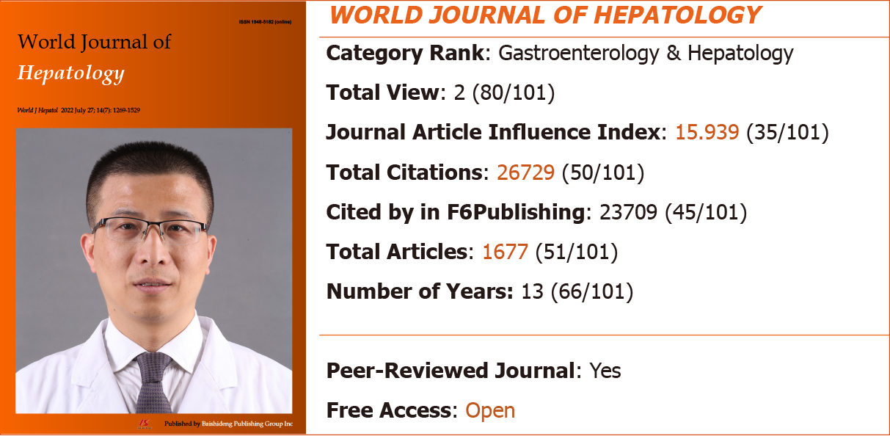
Figure 5 The 2022 Journal Article Influence Index and category rank of World Journal of Hepatology.

3.4 Author sources for WJH published articles in 2019-2021
From 2019 to 2021, the authors of the 346 articles published in WJH came from 60 countries/regions, represented by 107 articles (30.9%) from United States, 27 (7.8%) from the Brazil, 21 (6.1%) from United Kingdom, 20 (5.8%) from India, 18 (5.2%) from Italy, 17 (4.9%) from Egypt, 15 (4.3%) from Japan, 12 (3.5%) from Spain, 11 (3.2%) from China, 10 (2.9%) from France, 8 (2.3%) from Germany, 8 (2.3%) from Thailand, and 72 (20.8%) from other countries/regions (data from Web of Science, Figure 6).

Figure 6 Country sources and number of articles published in World Journal of Hepatology in 2019-2021. WJH: World Journal of Hepatology.

3.5 Number of webpage visits and downloads received by WJH in 2019-2021
From 2019 to 2021, the WJH webpage received a total number of visits of 232289 in 2019, 267963 in 2020 (increased by 15.4% compared with that in 2019), and 307146 in 2021 (increased by 14.6% compared with that in 2020), with the visits coming from more than 200 countries and regions worldwide (Table 9). The number of downloads was 165492 in 2019, 275254 in 2020 (increased by 66.3% compared with that in 2019), and 449831 in 2021 (increased by 63.4% compared with that in 2020), with the downloads coming from more than 160 countries and regions worldwide.

Table 9 Rank of number of visits for World Journal of Hepatology webpage from main countries/regions in 2019-2021
Rank | 2019 |  | 2020 |  | 2021
 | Country/region | Visits, n (%) | Country/region | Visits, n (%) | Country/region | Visits, n (%)
1 | United States | 52578 (22.6) | United States | 50346 (18.8) | United States | 86899 (28.3)
2 | China | 41994 (18.1) | China | 36337 (13.6) | China | 36347 (11.8)
3 | United Kingdom | 22156 (9.5) | United Kingdom | 24061 (9.0) | India | 17863 (5.8)
4 | Russia | 19946 (8.6) | Russia | 13566 (5.1) | South Korea | 13089 (4.3)
5 | Germany | 10630 (4.6) | Germany | 13515 (5.0) | United Kingdom | 11617 (3.8)
6 | India | 8962 (3.9) | India | 9636 (3.6) | Germany | 8959 (2.9)
7 | Ukraine | 8787 (3.8) | Hong Kong | 6425 (2.4) | Russia | 8810 (2.9)
8 | South Korea | 4584 (2.0) | South Korea | 3992 (1.5) | Japan | 6047 (2.0)
9 | Netherlands | 4110 (1.8) | Egypt | 3609 (1.3) | Brazil | 5707 (1.9)
10 | France | 3496 (1.5) | Taiwan | 3384 (1.3) | Netherlands | 5695 (1.9)

4 Number of received and published articles, ESCI citations data, 2022 JAII, author sources, and number of webpage visits and downloads for WJC in 2019-2021
4.1 Number of received and published articles of WJC in 2019-2021
From 2019 to 2021, WJC received a total of 375 articles, among which 175 (46.7%) were invited and 200 (53.3%) were freely submitted; the acceptance rate was 42.1%. During that same period, WJC published 158 articles, among which 91 (57.6%) were invited and 67 (42.4%) were freely submitted. The number of articles received in WJC in 2021 was 31.9% higher than that in the years of 2019-2020 (2019-2020 average: 113/year vs 2021: 149/year), and the number of articles published in WJC in 2021 was 51.1% higher than that in the years of 2019-2020 (2019-2020 average: 45/year vs 2021: 68/year).

4.2 ESCI citations for WJC published articles in 2019-2021
According to the Web of Science, Web of Science included a total of 335 articles published in WJC from 2017 to August 24, 2022. These articles have been cited 1858 times (Without self-citations: 1831) by 1780 articles (Without self-citations: 1759), average per item is 5.55.
As of August 24, 2022, the 158 articles published in WJC in 2019-2021 received a total of 468 citations (without self-citations: 463) by 458 articles (without self-citations: 454), yielding a self-citation rate of 1.07%; there were a total of 205 citations in 2021 and 165 citations in 2022 (data from Web of Science). After excluding self-citations, the 454 articles that cited the WJC-published articles were from 390 journals (data from Web of Science, Table 10); among these journals, 16 (4.1%) had a JIF of > 10 (data from Web of Science, Table 11), accounting for 2.4% of the 660 total journals that had received a JIF of > 10 in the JCR 2022. Moreover, the journals citing the WJC-published articles include internationally renowned academic journals such as Nature Reviews Gastroenterology Hepatology (2021 JIF 73.082, record count: 1), Nature Reviews Neurology (2021 JIF 44.711, record count: 1), Journal of the American College of Cardiology (2021 JIF 27.203, record count: 3), and Journal of Clinical Investigation (2021 JIF 19.456, record count: 1).

Table 10 Rank and record count of journals that published articles that cited the 158 articles published in World Journal of Cardiology in 2019-2021
Rank | Publication/source titles | Record count | % of 454
1 | Cureus | 14 | 3.084
2 | Journal of Clinical Medicine | 13 | 2.863
3 | Cureus Journal of Medical Science | 10 | 2.203
4 | Frontiers in Cardiovascular Medicine | 9 | 1.982
5 | Cells | 8 | 1.762
12 | Catheterization and Cardiovascular Interventions | 8 | 1.762
6 | International Journal of Molecular Sciences | 8 | 1.762
7 | International Journal of Environmental Research and Public Health | 7 | 1.542
8 | Frontiers in Physiology | 6 | 1.322
17 | American Journal of Emergency Medicine | 6 | 1.322
18 | Annals of Medicine and Surgery | 6 | 1.322
15 | American Journal of Cardiology | 6 | 1.322
22 | Diagnostics | 6 | 1.322
28 | Journal of Interventional Cardiac Electrophysiology | 6 | 1.322
9 | Biomedicines | 5 | 1.101
10 | Journal of Cardiovascular Development and Disease | 5 | 1.101
11 | PLOS One | 5 | 1.101
14 | Clinical Case Reports | 4 | 0.881
16 | American Journal of Cardiovascular Disease | 3 | 0.661
20 | Brain Sciences | 3 | 0.661
21 | Chest | 3 | 0.661
24 | Expert Review of Cardiovascular Therapy | 3 | 0.661
25 | Frontiers in Pharmacology | 3 | 0.661
26 | International Journal of Cardiology | 3 | 0.661
27 | Journal of Cardiac Surgery | 3 | 0.661
30 | Journal of the American College of Cardiology | 3 | 0.661
31 | Pharmacological Research | 3 | 0.661
32 | Reviews in Cardiovascular Medicine | 3 | 0.661
21 | Other journals | 292 | 64.317

Table 11 Rank and record count of the 16 journals with a 2021 Journal Impact Factor of > 10 that cited the articles published in World Journal of Cardiology in 2019-2021
Rank | Publication/source titles | 2021 JIF | Record count
1 | Nature Reviews Gastroenterology Hepatology | 73.082 | 1
2 | Nature Reviews Neurology | 44.711 | 1
3 | Journal of the American College of Cardiology | 27.203 | 3
4 | Journal of Clinical Investigation | 19.456 | 1
5 | Pharmacology Therapeutics | 13.400 | 1
6 | Cardiovascular Research | 13.081 | 1
7 | JACC Heart Failure | 12.544 | 1
8 | Journal for Immunotherapy of Cancer | 12.469 | 1
9 | Medicinal Research Reviews | 12.388 | 1
10 | Journal of Cachexia Sarcopenia and Muscle | 12.063 | 1
11 | Journal of Controlled Release | 11.467 | 1
12 | Drugs | 11.431 | 1
13 | Progress in Cardiovascular Diseases | 11.278 | 1
14 | Pharmacological Research | 10.334 | 3
15 | Chest | 10.262 | 3
16 | Translational Research | 10.171 | 1

Of note, the article entitled ”Frailty, sarcopenia and cachexia in heart failure patients: Different clinical entities of the same painting”, which was contributed by Dr. Matteo Beltrami et al^{[5]} from San Giovanni di Dio Hospital in the Italy, is the article with the highest number of citations among the articles published in WJC in 2021. This article reviews current knowledge on frailty, sarcopenia and cachexia in heart failure patients with the attempt to define clinically significant degrees of multiorgan dysfunction, specific "red alert" thresholds in clinical practice and therapeutic approach. As of August 24, 2022, this article has been cited 7 times.

4.3 2022 JAII of WJC
According to RCA database, WJC has a 2022 JAII of 12.930 ranking 52nd out of 163 journals in the field of cardiac & cardiovascular systems in the RCA, with 12361 total citations (99/163) and 956 total articles (124/163) (Figure 7).
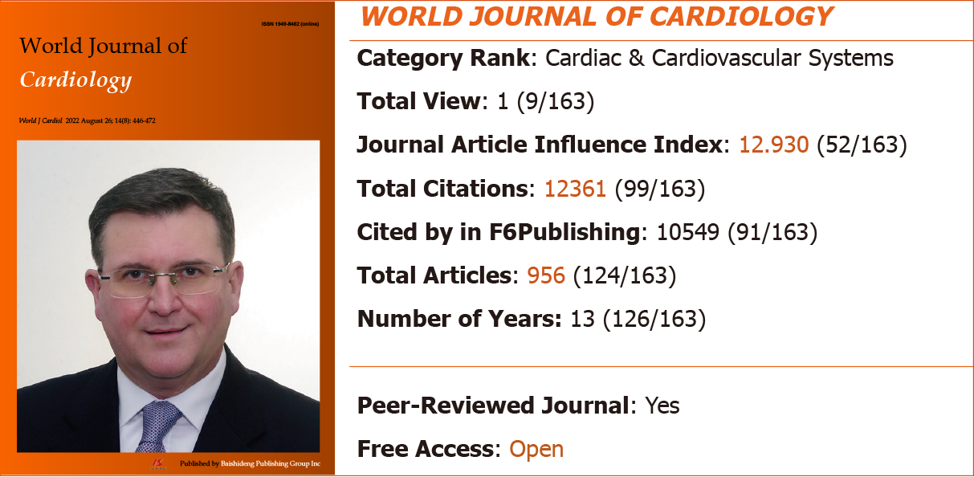
Figure 7 The 2022 Journal Article Influence Index and category rank of World Journal of Cardiology.

4.4 Author sources for WJC published articles in 2019-2021
From 2019 to 2021, the authors of the 158 articles published in WJC came from 34 countries/regions, represented by 69 articles (43.7%) from United States, 16 (10.1%) from the United Kingdom, 15 (9.5%) from Greece, 12 (7.6%) from Italy, 8 (5.1%) from Spain, 7 (4.4%) from Japan, 6 (3.8%) from India, 6 (3.8%) from Scotland, 5 (3.2%) from Germany, and 14 (8.9%) from other countries/regions (data from Web of Science, Figure 8).

Figure 8 Country sources and number of articles published in World Journal of Cardiology in 2019-2021. WJC: World Journal of Cardiology.

4.5 Number of webpage visits and downloads received by WJC in 2019-2021
From 2019 to 2021, the WJC webpage received a total number of visits of 128076 in 2019, 163984 in 2020 (increased by 28.0% compared with that in 2019), and 187866 in 2021 (increased by 14.6% compared with that in 2020), with the visits coming from more than 200 countries and regions worldwide (Table 12). The number of downloads was 79416 in 2019, 150634 in 2020 (increased by 89.7% compared with that in 2019), and 198255 in 2021 (increased by 31.6% compared with that in 2020), with the downloads coming from more than 140 countries and regions worldwide.

Table 12 Rank of number of visits for World Journal of Cardiology webpage from main countries/regions in 2019-2021
Rank | 2019 |  | 2020 |  | 2021
 | Country/region | Visits, n (%) | Country/region | Visits, n (%) | Country/region | Visits, n (%)
1 | United States | 33226 (25.9) | United States | 33671 (20.5) | United States | 56615 (30.1)
2 | China | 21115 (16.5) | United Kingdom | 20230 (12.3) | China | 20575 (11.0)
3 | United Kingdom | 16134 (12.6) | China | 18635 (11.4) | India | 9284 (4.9)
4 | Russia | 9728 (7.6) | Russia | 10985 (6.7) | United Kingdom | 8953 (4.8)
5 | India | 4869 (3.8) | India | 5076 (3.1) | Russia | 6675 (3.6)
6 | Ukraine | 4552 (3.6) | Germany | 4950 (3.0) | Germany | 6058 (3.2)
7 | Germany | 3453 (2.7) | Hong Kong | 3876 (2.4) | South Korea | 5340 (2.8)
8 | South Korea | 2544 (2.0) | Australia | 2539 (1.5) | Canada | 4255 (2.3)
9 | Netherlands | 2268 (1.8) | Netherlands | 2355 (1.4) | Australia | 3986 (2.1)
10 | France | 2243 (1.8) | Canada | 2319 (1.4) | Netherlands | 3954 (2.1)

5 Number of received and published articles, ESCI citations data, 2022 JAII, author sources, and number of webpage visits and downloads for WJGE in 2019-2021
5.1 Number of received and published articles of WJGE in 2019-2021
From 2019 to 2021, WJGE received a total of 359 articles, among which 148 (41.2%) were invited and 211 (58.8%) were freely submitted; the acceptance rate was 48.5%. During that same period, WJGE published 174 articles, among which 84 (48.3%) were invited and 90 (51.7%) were freely submitted. The number of articles received in WJGE in 2021 was 24.3% higher than that in the years of 2019-2020 (2019-2020 average: 111/year vs 2021: 138/year), and the number of articles published in WJGE in 2021 was 7.0% higher than that in the years of 2019-2020 (2019-2020 average: 57/year vs 2021: 61/year).

5.2 ESCI citations for WJGE published articles in 2019-2021
According to the Web of Science, Web of Science included a total of 332 articles published in WJGE from 2017 to August 24, 2022. These articles have been cited 1735 times (Without self-citations: 1693) by 1646 articles (Without self-citations: 1613), average per item is 5.23.
As of August 24, 2022, the 174 articles published in WJGE in 2019-2021 received a total of 616 citations (without self-citations: 601) by 582 articles (without self-citations: 569), yielding a self-citation rate of 2.44%; there were a total of 254 citations in 2021 and 170 citations in 2022 (data from Web of Science). After excluding self-citations, the 569 articles that cited the WJGE-published articles were from 325 journals (data from Web of Science, Table 13); among these journals, 9 (2.8%) had a JIF of > 10 (data from Web of Science, Table 14), accounting for 1.4% of the 660 total journals that had received a JIF of > 10 in the JCR 2022. Moreover, the journals citing the WJGE-published articles include internationally renowned academic journals such as JAMA (2021 JIF 157.335, record count: 1), Lancet Oncology (2021 JIF 54.433, record count: 1), Journal of the American Academy of Dermatology (2021 JIF 15.487, record count: 1), and Clinical Gastroenterology and Hepatology (2021 JIF 13.576, record count: 2).

Table 13 Rank and record count of journals that published articles that cited the 174 articles published in World Journal of Gastrointestinal Endoscopy in 2019-2021
Rank | Publication/source titles | Record count | % of 569
1 | Gastrointestinal Endoscopy | 26 | 4.569
2 | Digestive Endoscopy | 24 | 4.218
3 | Endoscopy | 19 | 3.339
4 | Diagnostics | 18 | 3.163
5 | Endoscopy International Open | 15 | 2.636
6 | Surgical Endoscopy | 15 | 2.636
7 | Surgical Endoscopy and Other Interventional Techniques | 15 | 2.636
8 | Clinical Endoscopy | 14 | 2.460
9 | Obesity Surgery | 13 | 2.285
10 | American Journal of Gastroenterology | 12 | 2.109
11 | World Journal of Gastroenterology | 12 | 2.109
12 | Cureus | 11 | 1.933
13 | Endoscopia | 9 | 1.582
14 | Endoscopic Ultrasound | 9 | 1.582
15 | BMC Gastroenterology | 8 | 1.406
16 | Cancers | 8 | 1.406
17 | Chinese Journal of Digestive Endoscopy | 8 | 1.406
18 | Clinical Journal of Gastroenterology | 6 | 1.054
19 | Cureus Journal of Medical Science | 6 | 1.054
20 | Journal of Clinical Medicine | 6 | 1.054
21 | World Journal of Clinical Cases | 6 | 1.054
22 | Other journals | 309 | 54.306

Table 14 Rank and record count of the 9 journals with a 2021 Journal Impact Factor of > 10 that cited the articles published in World Journal of Gastrointestinal Endoscopy in 2019-2021
Rank | Publication/source titles | 2021 JIF | Record count
1 | JAMA | 157.335 | 1
2 | Lancet Oncology | 54.433 | 1
3 | Journal of the American Academy of Dermatology | 15.487 | 1
4 | Clinical Gastroenterology and Hepatology | 13.576 | 2
5 | Medical Journal of Australia | 12.776 | 1
6 | American Journal of Gastroenterology | 12.045 | 12
7 | British Journal of Surgery | 11.122 | 1
8 | Gastrointestinal Endoscopy | 10.396 | 24
9 | Chest | 10.262 | 1

Of note, the article entitled ”Gastrointestinal amyloidosis: A focused review”, which was contributed by Dr. Dushyant Singh Dahiya et al^{[6]} from Central Michigan University in the United States, is the article with the highest number of citations among the articles published in WJGE in 2021. This article describes the subtypes of amyloidosis, with a primary focus on the epidemiology, pathogenesis, clinical features, diagnosis and treatment strategies available for gastrointestinal amyloidosis. As of August 24, 2022, this article has been cited 7 times.

5.3 2022 JAII of WJGE
According to RCA database, WJGE has a 2022 JAII of 10.698 ranking 62nd out of 101 journals in the field of gastroenterology & hepatology in the RCA, with 11393 total citations (64/101) and 1065 total articles (71/101) (Figure 9).
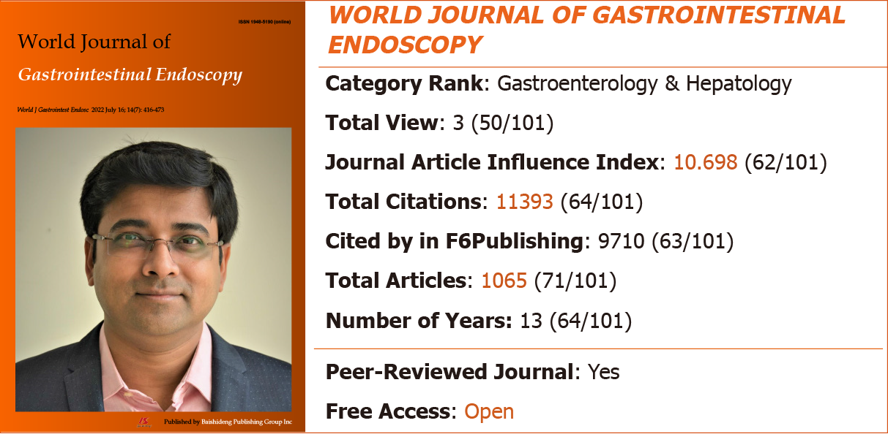
Figure 9 The 2022 Journal Article Influence Index and category rank of World Journal of Gastrointestinal Endoscopy.

5.4 Author sources for WJGE published articles in 2019-2021
From 2019 to 2021, the authors of the 174 articles published in WJGE came from 40 countries/regions, represented by 74 articles (42.5%) from United States, 23 (13.2%) from the Japan, 20 (11.5%) from Italy, 15 (8.6%) from Brazil, 13 (7.5%) from United Kingdom, 4 (2.3%) from Greece, 4 (2.3%) from India, 4 (2.3%) from China, and 17 (9.8%) from other countries/regions (data from Web of Science, Figure 10).

Figure 10 Country sources and number of articles published in World Journal of Gastrointestinal Endoscopy in 2019-2021. WJGE: World Journal of Gastrointestinal Endoscopy.

5.5 Number of webpage visits and downloads received by WJGE in 2019-2021
From 2019 to 2021, the WJGE webpage received a total number of visits of 158515 in 2019, 216930 in 2020 (increased by 36.9% compared with that in 2019), and 174499 in 2021 (decreased by 19.6% compared with that in 2020), with the visits coming from more than 190 countries and regions worldwide (Table 15). The number of downloads was 84343 in 2019, 141046 in 2020 (increased by 67.2% compared with that in 2019), and 219456 in 2021 (increased by 55.6% compared with that in 2020), with the downloads coming from more than 140 countries and regions worldwide.

Table 15 Rank of number of visits for WJGE webpage from main countries/regions in 2019-2021
Rank | 2019 |  | 2020 |  | 2021
 | Country/region | Visits, n (%) | Country/region | Visits, n (%) | Country/region | Visits, n (%)
1 | United States | 42667 (26.9) | United States | 44762 (20.6) | United States | 54685 (31.3)
2 | China | 24517 (15.5) | United Kingdom | 44019 (20.3) | China | 18691 (10.7)
3 | United Kingdom | 19012 (12.0) | China | 18378 (8.5) | India | 9127 (5.2)
4 | Russia | 13499 (8.5) | Russia | 17008 (7.8) | South Korea | 9127 (5.2)
5 | Ukraine | 6284 (4.0) | India | 6313 (2.9) | United Kingdom | 6601 (3.8)
6 | India | 6008 (3.8) | Germany | 5186 (2.4) | Japan | 5275 (3.0)
7 | South Korea | 3861 (2.4) | Hong Kong | 4355 (2.0) | Russia | 4433 (2.5)
8 | Germany | 3482 (2.2) | Japan | 3256 (1.5) | Germany | 4028 (2.3)
9 | Netherlands | 2972 (1.9) | South Korea | 3102 (1.4) | Canada | 3379 (1.9)
10 | Japan | 2478 (1.6) | Netherlands | 2906 (1.3) | Netherlands | 3134 (1.8)

6 Number of received and published articles, ESCI citations data, 2022 JAII, author sources, and number of webpage visits and downloads for WJR in 2019-2021
6.1 Number of received and published articles of WJR in 2019-2021
From 2019 to 2021, WJR received a total of 183 articles, among which 90 (49.2%) were invited and 93 (50.8%) were freely submitted; the acceptance rate was 37.7%. During that same period, WJR published 69 articles, among which 46 (66.7%) were invited and 23 (33.4%) were freely submitted. The number of articles received in WJR in 2021 was 5.0% higher than that in the years of 2019-2020 (2019-2020 average: 60/year vs 2021: 63/year), and the number of articles published in WJR in 2021 was 33.3% higher than that in the years of 2019-2020 (2019-2020 average: 21/year vs 2021: 28/year).

6.2 ESCI citations for WJR published articles in 2019-2021
According to the Web of Science, Web of Science included a total of 167 articles published in WJR from 2017 to August 24, 2022. These articles have been cited 1041 times (Without self-citations: 1017) by 1025 articles (Without self-citations: 1009), average per item is 6.23.
As of August 24, 2022, the 69 articles published in WJR in 2019-2021 received a total of 276 citations (without self-citations: 264) by 261 articles (without self-citations: 254), yielding a self-citation rate of 1.14%; there were a total of 128 citations in 2021 and 102 citations in 2022 (data from Web of Science). The 254 articles that cited the WJR-published articles were from 233 journals (data from Web of Science, Table 16); among these journals, 12 (5.2%) had a JIF of > 10 (data from Web of Science, Table 17), accounting for 1.8% of the 660 total journals that had received a JIF of > 10 in the JCR 2022. Moreover, the journals citing the WJR-published articles include internationally renowned academic journals such as Signal Transduction and Targeted Therapy (2021 JIF 38.104, record count: 1), Nature Reviews Rheumatology (2021 JIF 32.286, record count: 1), Trends in Molecular Medicine (2021 JIF 15.272, record count: 1), Medical Journal of Australia (2021 JIF 12.776, record count: 2), and American Journal of Gastroenterology (2021 JIF 12.045, record count: 2).

Table 16 Rank and record count of journals that published articles that cited the 69 articles published in World Journal of Radiology in 2019-2021
Rank | Publication/source titles | Record count | % of 254
1 | Diagnostics | 18 | 7.087
2 | British Journal of Radiology | 6 | 2.362
3 | Journal of Ultrasound in Medicine | 6 | 2.362
4 | Seminars in Ultrasound CT and MRI | 6 | 2.362
5 | Academic Radiology | 5 | 1.969
6 | European Journal of Radiology | 4 | 1.575
7 | Journal of Clinical Medicine | 4 | 1.575
8 | Applied Sciences Basel | 3 | 1.181
9 | Cancers | 3 | 1.181
10 | Cureus | 3 | 1.181
11 | Frontiers in Medicine | 3 | 1.181
12 | Frontiers in Oncology | 3 | 1.181
13 | Journal of Personalized Medicine | 3 | 1.181
14 | Scientific Reports | 3 | 1.181
15 | Other journals | 184 | 72.441

Table 17 Rank and record count of the 12 journals with a 2021 Journal Impact Factor of > 10 that cited the articles published in World Journal of Radiology in 2019-2021
Rank | Publication/source titles | 2021 JIF | Record count
1 | Signal Transduction and Targeted Therapy | 38.104 | 1
2 | Nature Reviews Rheumatology | 32.286 | 1
3 | Trends in Molecular Medicine | 15.272 | 1
4 | Medical Journal of Australia | 12.776 | 2
5 | American Journal of Gastroenterology | 12.045 | 2
6 | Journal of Controlled Release | 11.467 | 1
7 | Advanced Healthcare Materials | 11.092 | 1
8 | Journal of Allergy and Clinical Immunology in Practice | 11.022 | 2
9 | Clinical Nuclear Medicine | 10.782 | 2
10 | Nano Research | 10.269 | 1
11 | Clinical Immunology | 10.190 | 1
12 | Stroke | 10.170 | 1

Of note, the article entitled ”Radiological and clinical spectrum of COVID-19: A major concern for public health”, which was contributed by Dr. Henu Kumar Verma^{[7]} from Institute of Experimental Endocrinology and Oncology CNR in the Italy, is the article with the highest number of citations among the articles published in WJR in 2021. This article summarizes the possible understanding of the various pathophysiology, radio diagnostic methods in severe coronavirus disease 2019 patients. As of August 24, 2022, this article has been cited 6 times.

6.3 2022 JAII of WJR
According to RCA database, WJR has a 2022 JAII of 14.997 ranking 46th out of 161 journals in the field of radiology, nuclear medicine & medical imaging in the RCA, with 10573 total citations (101/161) and 705 total articles (133/161) (Figure 11).
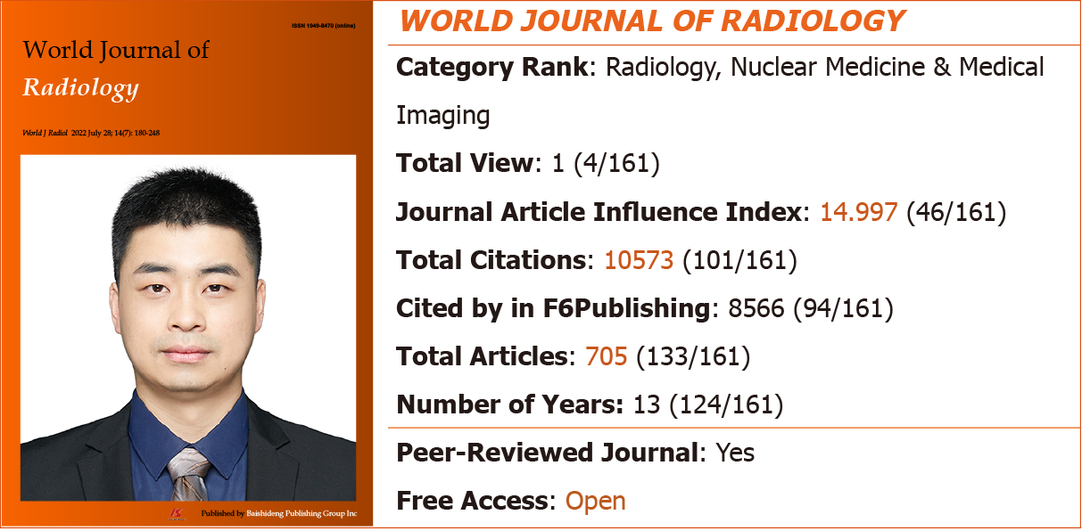
Figure 11 The 2022 Journal Article Influence Index and category rank of World Journal of Radiology.

6.4 Author sources for WJR published articles in 2019-2021
From 2019 to 2021, the authors of the 69 articles published in WJR came from 28 countries/regions, represented by 27 articles (39.1%) from United States, 8 (11.6%) from the Italy, 6 (8.7%) from the India, 4 (5.8%) from the United Kingdom, 4 (5.8%) from the Germany, 4 (5.8%) from Spain, and 16 (23.2%) from other countries/regions (data from Web of Science, Figure 12).

Figure 12 Country sources and number of articles published in World Journal of Radiology in 2019-2021. WJR: World Journal of Radiology.

6.5 Number of webpage visits and downloads received by WJR in 2019-2021
From 2019 to 2021, the WJR webpage received a total number of visits of 154498 in 2019, 176347 in 2020 (increased by 14.1% compared with that in 2019), and 211681 in 2021 (decreased by 20.0% compared with that in 2020), with the visits coming from more than 200 countries and regions worldwide (Table 18). The number of downloads was 69708 in 2019, 157541 in 2020 (increased by 126.0% compared with that in 2019), and 165318 in 2021 (increased by 4.9% compared with that in 2020), with the downloads coming from more than 140 countries and regions worldwide.

Table 18 Rank of number of visits for World Journal of Radiology webpage from main countries/regions in 2019-2021
Rank | 2019 |  | 2020 |  | 2021
 | Country/region | Visits, n (%) | Country/region | Visits, n (%) | Country/region | Visits, n (%)
1 | United States | 42549 (27.5) | United States | 39974 (22.7) | United States | 65300 (30.8)
2 | United Kingdom | 18243 (11.8) | China | 16906 (9.6) | India | 18806 (8.9)
3 | China | 17369 (11.2) | United Kingdom | 12629 (7.2) | China | 16304 (7.7)
4 | India | 11067 (7.2) | India | 11155 (6.3) | South Korea | 10056 (4.8)
5 | Russia | 7525 (4.9) | Russia | 6642 (3.8) | United Kingdom | 6964 (3.3)
6 | South Korea | 4520 (2.9) | Hong Kong | 4648 (2.6) | Russia | 5611 (2.7)
7 | Ukraine | 3390 (2.2) | Germany | 4192 (2.4) | Germany | 5042 (2.4)
8 | Germany | 2939 (1.9) | South Korea | 3751 (2.1) | Netherlands | 4395 (2.1)
9 | Netherlands | 2786 (1.8) | Australia | 2706 (1.5) | Canada | 3913 (1.8)
10 | Canada | 2415 (1.6) | Canada | 2646 (1.5) | Australia | 3813 (1.8)

7 Conclusion
With the supports of the editorial board, peer reviewers, authors, readers and editors of Baishideng, the six journals have been developed a lot: (1) Compared with 2019-2020, the number of articles received, articles published of the six journals have significantly increased in 2021. Such as, the number of articles received in WJH in 2021 was 93.2% higher than that in the years of 2019-2020, and the number of articles published in WJH in 2021 was 73.1% higher than that in the years of 2019-2020; (2) According to the Web of Science, the average times cited per item of the six journals are all > 5. Such as, from 2017 to August 24, 2022, the Web of Science included a total of 672 articles published in WJH. These articles have been cited 5496 times, the average per item is 8.18; (3) Some of the articles published in the six journals in 2019-2021 have been cited by articles published in internationally renowned academic journals, such as JAMA (2021 JIF 157.335), Nature Reviews Gastroenterology Hepatology (2021 JIF 73.082), Nature Reviews Clinical Oncology (2021 JIF 65.011), and Lancet Oncology (2021 JIF 54.433), etc.; (4) According to the RCA, the 2022 JAII of the six journals are all > 10. Such as, WJO has a 2022 JAII of 15.410, ranking 31st out of 104 journals in the field of orthopedics in the RCA; (5) Most of the authors of the articles published in the six journals in 2019-2021 are came from developed countries, such as United States (33.9%, 397/1171), and United Kingdom (7.8%, 91/1171), etc.; and (6) The number of webpage visits and downloads received of the six journals have significantly increased in year by year. Such as, WJCO received visits from more than 180 countries and regions worldwide, and the number of visits in 2020 increased by 46.6% compared with that in 2019, the number of visits in 2021 increased by 29.1% compared with that in 2020. The downloads of WJO came from more than 160 countries and regions worldwide, and the number of downloads in 2020 increased by 91.8% compared with that in 2019, the number of downloads in 2021 increased by 41.7% compared with that in 2020. Thank you all for your support and contribution!
In the future, Baishideng will continue take publishing high-quality innovative researches and achievements as our responsibility, with a rigorous attitudes and high-standard service to provide a high efficacy academic publishing platform for the global scientific researchers. At last, we wish that the six ESCI indexed journals of Baishideng will receive good JIFs in 2023.

About RCA
RCA is an AI technology-based open multidisciplinary citation analysis database. As such, RCA will lead the development of wisdom, knowledge innovation, and emerging disciplines. The functions of RCA include: Find an Article (55579975), Find a Category (254), Find a Journal (14077), Find a Scholar (632), and Find an Academic Assistant (18). RCA updates its list of journals daily, according to relevant data including total number of articles, total citations, and JAII. RCA acquires the newly released abstracts and references from Crossref and adds them to the RCA database weekly. RCA also acquires the abstracts and references released that year from Crossref and adds them to the RCA database monthly, and then updates the total number of articles, citations, and JAII.

About the Baishideng
Baishideng Publishing Group (Baishideng), founded on January 15, 1993, is a biomedical publishing company accredited by the Committee on Publication Ethics, editing and publishing more than 47 academic journals in Chinese and English. All of the Baishideng's academic journals are published using an open access and single-blind external peer-review model, with some high quality academic journals being included in the Science Citation Index Expanded, Emerging Sources Citation Index, MEDLINE, PubMed, PubMed Central, Scopus, Reference Citation Analysis (RCA), and other important databases. Baishideng has the industry leading F6Publishing system, which has the functions covering the whole publication process from manuscript submission to online publishing, including article quality tracking system, author evaluation system, and reader evaluation system. In addition, Baishideng has the world's only RCA system, an open and transparent high-quality academic article evaluation service platform for various categories that is freely available to authors and readers. The functions of RCA include: Find an article, find a category, find a journal, find a scholar, and find an academic assistant.

REFERENCES
1 Quaderi N. Announcing changes to the 2023 Journal Citation Reports. [accessed 2022 August 24]. Available from: https://clarivate.com/blog/clarivate-announces-changes-to-the-2023-journal-citation-reports-release/
2 de Sire A, Invernizzi M, Baricich A, Lippi L, Ammendolia A, Grassi FA, Leigheb M. Optimization of transdisciplinary management of elderly with femur proximal extremity fracture: A patient-tailored plan from orthopaedics to rehabilitation. World J Orthop 2021; 12: 456-466 [PMID: 34354934 DOI: 10.5312/wjo.v12.i7.456]
3 Chevallier M, Borgeaud M, Addeo A, Friedlaender A. Oncogenic driver mutations in non-small cell lung cancer: Past, present and future. World J Clin Oncol 2021; 12: 217-237 [PMID: 33959476 DOI: 10.5306/wjco.v12.i4.217]
4 Boeva I, Karagyozov PI, Tishkov I. Post-liver transplant biliary complications: Current knowledge and therapeutic advances. World J Hepatol 2021; 13: 66-79 [PMID: 33584987 DOI: 10.4254/wjh.v13.i1.66]
5 Beltrami M, Fumagalli C, Milli M. Frailty, sarcopenia and cachexia in heart failure patients: Different clinical entities of the same painting. World J Cardiol 2021; 13: 1-10 [PMID: 33552398 DOI: 10.4330/wjc.v13.i1.1]
6 Dahiya DS, Kichloo A, Singh J, Albosta M, Wani F. Gastrointestinal amyloidosis: A focused review. World J Gastrointest Endosc 2021; 13: 1-12 [PMID: 33520102 DOI: 10.4253/wjge.v13.i1.1]
7 Verma HK. Radiological and clinical spectrum of COVID-19: A major concern for public health. World J Radiol 2021; 13: 53-63 [PMID: 33815683 DOI: 10.4329/wjr.v13.i3.53]

